Process Book (CS171 Week 11)

# Project Title: Ukraine Improvised Explosive Devices

# Project Team

Online Studio 3 Group 3

Valérie Lavigne

[valelavi@gmail.com](mailto:valelavi@gmail.com)

Marius Panga

[marius.c.panga@gmail.com](mailto:marius.c.panga@gmail.com)

Jayaram Shivas Vadakumpuram

[shivasj@gmail.com](mailto:shivasj@gmail.com)



## Team Roles

Team Coordinator: Valérie

* Producing a tasks list in Asana from the assignements for each week and making sure all the work is assigned

Code Collaborator: Shivas

* Setting up and organizing the Github repository
* Overall web app layout and designer

Data Stewart: Marius

* Identifying potentially relevant data from various sources, extracting, translating and transforming it to a format that is consistent and easy to merge with the main dataset.

Alternating Responsibilities

Role shared across team members, one team member volunteers each week:

* Team Submitter: Packaging the week’s work and submitting it
* Updating the process book
* Tasks for each week are listed in Asana and each team member volunteers for the tasks he/she wants to do, tasks assignment is also discussed at the weekly meting
* Updating the various supporting documents is done in a collaborative manner, with each member contributing in an agile way with relevant input.

# Project Description

## Background and Motivation

Valérie works as a defence scientist for Defence R&D Canada and is the Canadian representative on the NATO Research Task Group IST-141 Exploratory Visual Analytics. Through her work, she was exposed to a dataset and presentation about the Ukraine Improvised Explosive Devices (IED) situation produced by the NATO Counter-IED Center of Excellence (NATO C-IED COE) which is an International Military Organization, multinationally manned and funded by contributions from 9 sponsoring NATO nations (<http://www.coec-ied.es/>). Figures 1 and 2 below show current static visualization employed by the C-IED COE to visualize this data.

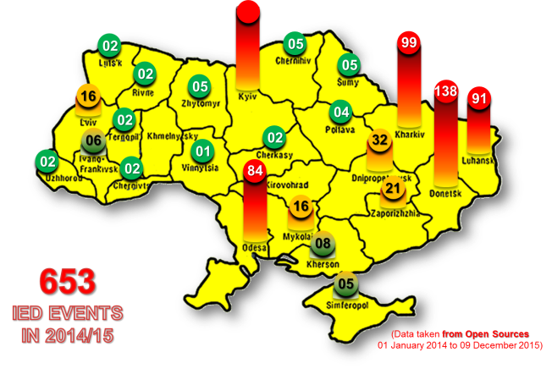

*Figure 1: Map of Ukraine IED incidents in 2014-2015.*

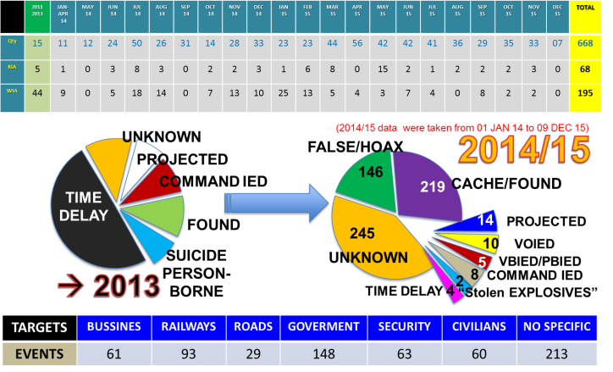

*Figure 2: Statistical data about Ukraine IED incidents in 2014-2015.*

Valérie, Marius and Shivas agreed that these visualizations could be improved upon using what they learned in the CS171 Visualization class. They decided to take the challenge of creating an interactive visualization for this data. The dataset is interesting because it contains many datatypes (quantitative, geographical, temporal, textual) and it can be augmented using additional data from the web. We intend to share the end result of our project with the NATO C-IED COE.

## Project Objectives and Goals

This project will allow the exploration of over 600 Improvised Explosive Devices incidents in Ukraine mostly over the past 2 years for the purpose of highlighting and better understanding the temporal, geographical and political patterns in that data. We will consider additional census data and election statistics to uncover potential regional patterns, as well as publicly available data about the existing conflict in Eastern Ukraine. We intend to employ interactive visualization to generate better insights about the Ukraine IED situation.

### Questions

By answering some or all of the questions below, our project aims to provide better insights into the Ukraine IDE situation:

* Is there a temporal pattern in the number of IED incidents?
* Where are the IED incidents located within Ukraine?
* How do the incidents relate to the conflict in Eastern Ukraine? Is there a relation between he number of incidents and the distance to the conflict zone and the political situation?
* Do the ratios of incidents remain stable over time between the different regions? Do the incidents seem to move from one region to another?
* How does the rate of IDE incidents relate to the total number of reported casualties and injuries?
* Do the different types of IEDs have interesting geo-temporal patterns?
* Is the number of incidents correlated with regional census data, more specifically:
  + Are there less or more incidents in Russian speaking regions?
  + Are there less or more incidents in poorer regions?
  + Is there a connections between the incidents and the political allegiance of the regions, according to the 2010 Presidential election data?
* Can we correlate any spikes or patterns in the data with political developments in the conflict (Crimea Annexation, agreed Ceasefire, Ukraine elections …)
* Is there any additional insight that can be obtained from the free-text incident description field in the main data source?

### Tasks

Following is a list of tasks that could be identified in this early phase of the project. As the project progresses, this list will evolve with more tasks being added and some becoming obsolete or irrelevant.

* Data analysis: go over all the candidate data sources and selecting the bits of data that will be relevant to the project
* Data gathering: while our main data source is already in a structured format, the additional sources are not(news articles, PDF files, images). This step involves getting all the relevant data into a structured format (txt or cvs files)
* Data cleaning: make sure the data that has been identified as relevant is in a consistent format. Standardize the handling of incorrect or missing data, as well as any formatting issues
* Data filtering: based on the data analysis outcome, remove any data that is needed for the visualization
* Data model design: identify the JavaScript entities that will contain / reference the source data, and for each such entity define:
  + - Relationship with other data (how will it merge with other data)
    - Properties (name and data type) and methods
    - Default sort order

# Data

## Data Description

### NATO Ukraine IED Incidents Data

This is a NATO Unclassified IED events spreadsheet from the NATO C-IED COE. It contains 665 events, with 15 in 2001-2013, about 230 in 2014 and the rest in 2015. It contains the following column headers: Date, Type, KIA (Killed in Action), WIA (Wounded in Action), City, Region, Country, Details, Remarks. There are missing values in the dataset. Table 1 below provides a sample of the data for December 2015.

*Table 1: Sample of the Ukraine IED incidents data for December 2015.*

|  |  |  |  |  |  |  |  |  |
| --- | --- | --- | --- | --- | --- | --- | --- | --- |
| **DATE** | **TYPE** | **KIA** | **WIA** | **CITY** | **REGION** | **COUNTRY** | **DETAILS** | **REMARKS** |
| 2015 DEC 09 | CACHE/FOUND | 0 | 0 | Kramatorsk | DONETSK | UKRAINE | IEDs were found and disposed by Combat Engineers | TBC if they were just landmines |
| 2015 DEC 09 | UNKNOWN | 0 | 0 | Kharkiv | KHARKIV | UKRAINE | An IED was blown up in front of a ROSHEN shop | Shopping Center |
| 2015 DEC 08 | UNKNOWN | 0 | 0 | Kiev | KIEV | UKRAINE | A device was detonated against a restaurant (L'Kafa) | Boulevard Lesi Ukrainian |
| 2015 DEC 07 | HOAX/FALSE | 0 | 0 | Ivano-Frankivsk | IVANO-FRANKIVSK | UKRAINE | Call reporting IED - First Responders action - no explosive | Central Metro/bus station |
| 2015 DEC 02 | CACHE/FOUND | 0 | 0 | Krasnoarmiisk | DONETSK | UKRAINE | An IED was found and disposed by EOD |  |
| 2015 DEC 02 | CACHE/FOUND | 0 | 0 | Avdeevka | DONETSK | UKRAINE | A cache with 3 IEDs with TNT was found and cleared | Inside an abandoned house |
| 2015 DEC 02 | UNKNOWN | 0 | 0 | Uzhgorod | ZAKARPATS'KA | UKRAINE | An IED was detonated against a store in Franko Street |  |

### Ukraine Census Data

We also want to include various statistics about Ukraine to see if we can find patterns between the IED events and these statistics. The data was cleansed and transformed in order to have the same grain and use the same common attributes as our primary data set (the NATO IED dataset). Transformations applied in order to facilitate the data merge with the other datasets: removed irrelevant data from the data set, converted all fields to the correct type, translated the region names to the ones used by the primary data set. The tool used to facilitate these transformations was Microsoft Power BI Desktop Designer.

1. Ukraine population by region and settlement type, as per January 1, 2013. The data was obtained from the Ukraine Census website <http://database.ukrcensus.gov.ua/MULT/Database/Census/databasetree_en.asp> ):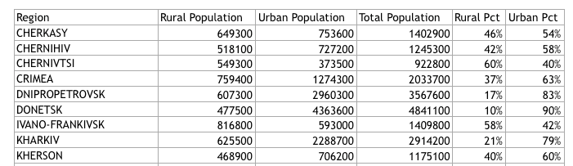
2. Percentage of the Ukraine population that have Russian as their native tongue, as of 2001, from the Ukraine Census website.

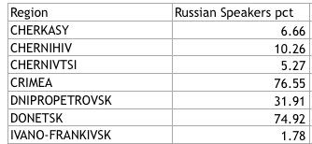

1. Ukraine population by region and education level, as of 1989. The data was obtained from the Ukraine Census website: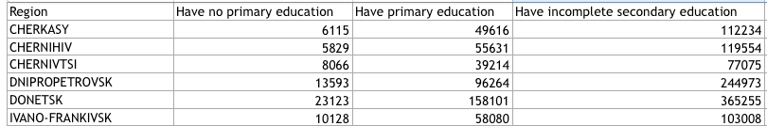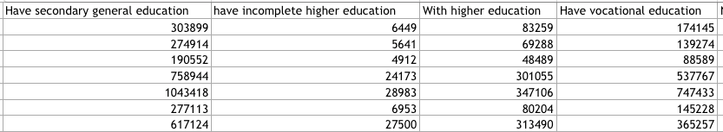
2. Ukraine population by region and source of income, as of 1989. The data was obtained from the Ukraine Census website:

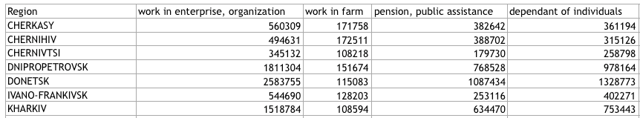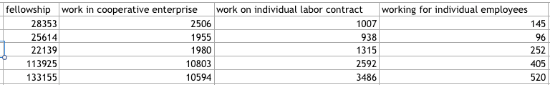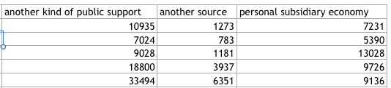

1. Ukraine population by region and nationality of income, as of 1989. For this exercise, only the Ukrainian and Russian nationalities were considered. The data was obtained from the Ukraine Census website: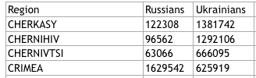

### Ukraine 2010 Presidential Elections Data

Since the Ukraine started with the removal from power of the previously elected president Viktor Yanukovych, we wish to provide the user with an underlying political map, based on the 2010 presidential elections. The source data has the same geographical grain as our main IED data set (region). Source: <https://commons.wikimedia.org/wiki/User:DemocracyATwork>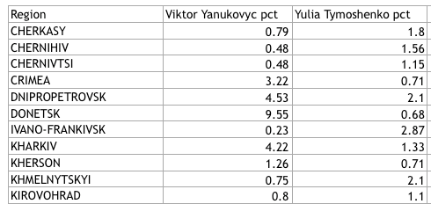

### Ukraine Map Data

We will a geojson/topojson data about the various regions of Ukraine as we expect some of this information might be displayed on a map. We have found two potentially suitable Ukraine map data files.

### Ukraine Conflict Casualties and Injuries Data

We will consider using this UN report in order to provide additional key facts about the Ukraine conflict (number of casualties and injuries by month), as well as to try to establish a relation between the number of casualties and injuries and the number if IED explosions. The data was available between 16 Feb 2015 and 15 Nov 2015. Source: <http://www.ohchr.org/Documents/Countries/UA/12thOHCHRreportUkraine.pdf>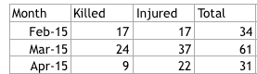

## Exploratory Data Analysis

### Tableau Data Analysis

Using Tableau, we explored the number of events, of persons killed and of persons wounded by region. The events are colored by type, which also highlights the presence of data errors like the “UNKKNOWN” label. We also explored the number of events happening in the 2014-2015 time period for each event type.

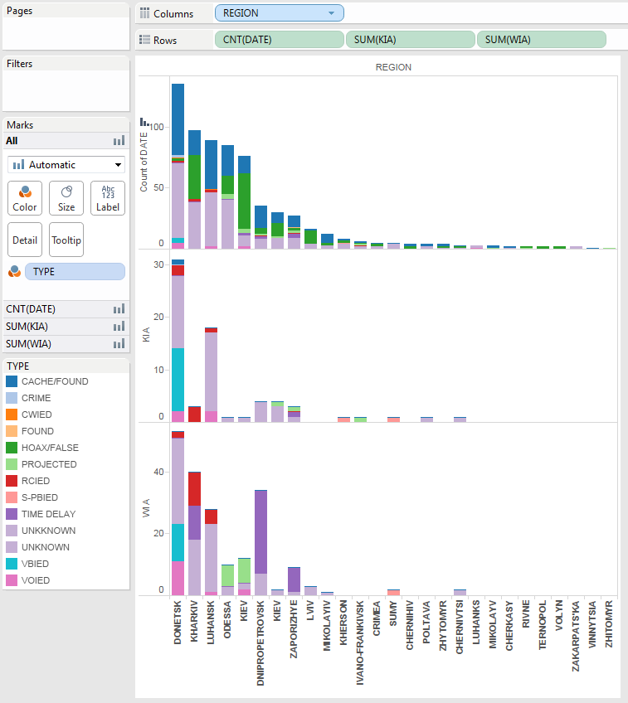

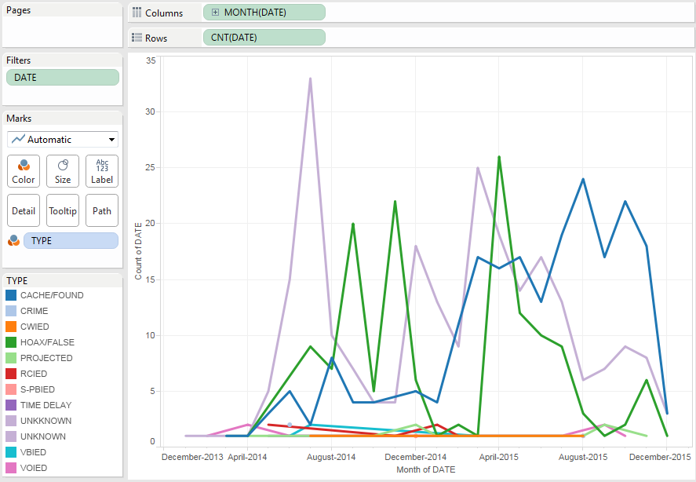

### Text Exploration

We produced a force layout to find relationships between the various IED event texts (details and remarks fields) and see the ones which have most unusual words in them.

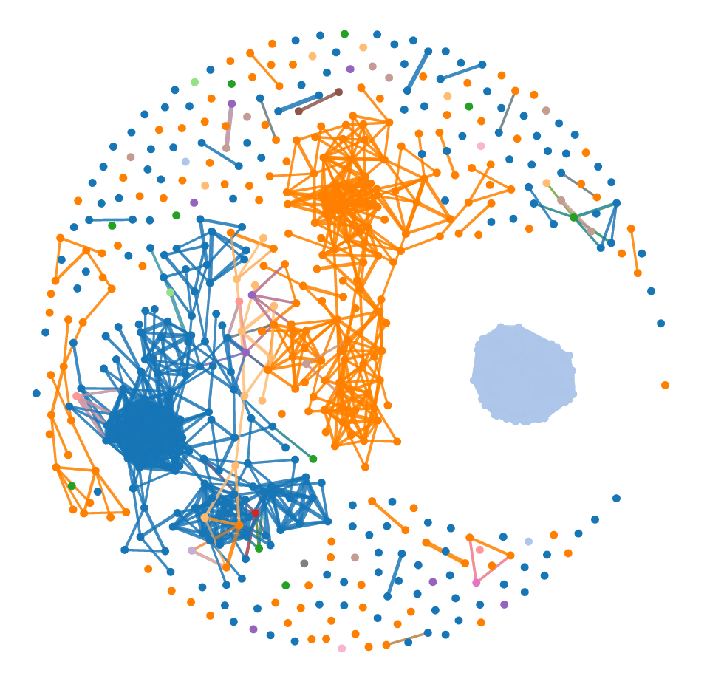

### Power BI Map

Using Power BI, we visualized the number of IED events by city and by regions.

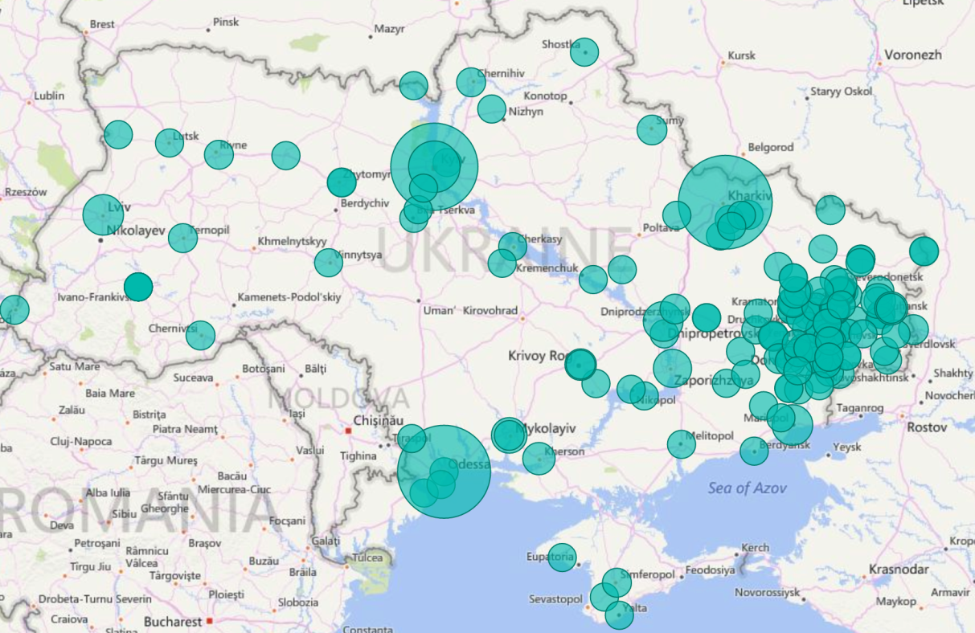

IED events by city

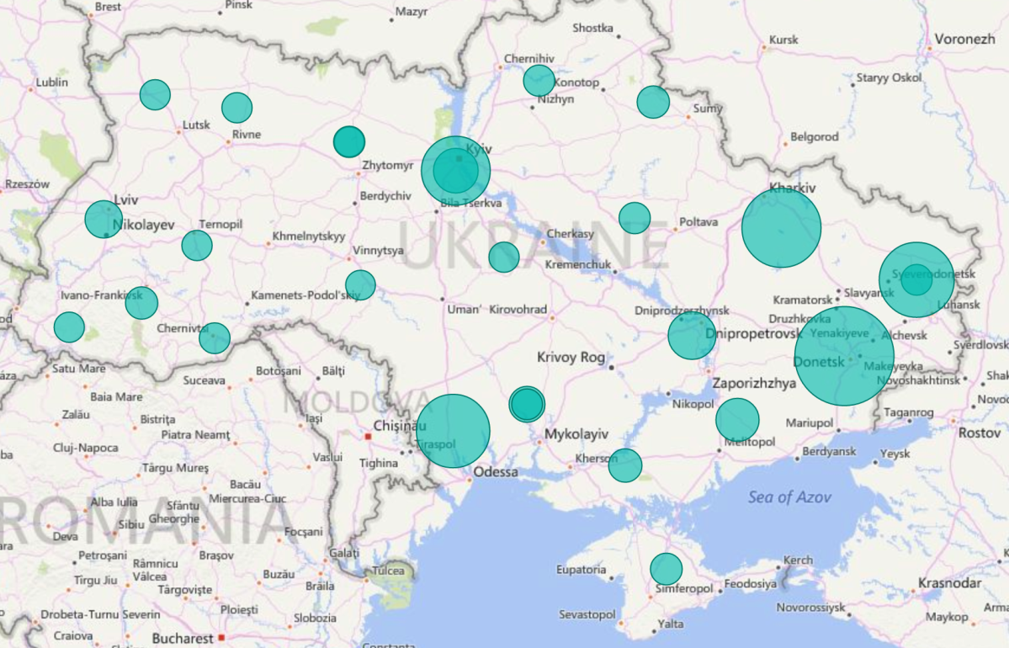

IED events by region

### Power BI Statistics

During the data collection exercise we used some graphics to explore and visualize the new dataset, as well as identify some early correlation between this dataset and the IDE dataset:

Graphical overview of the population data: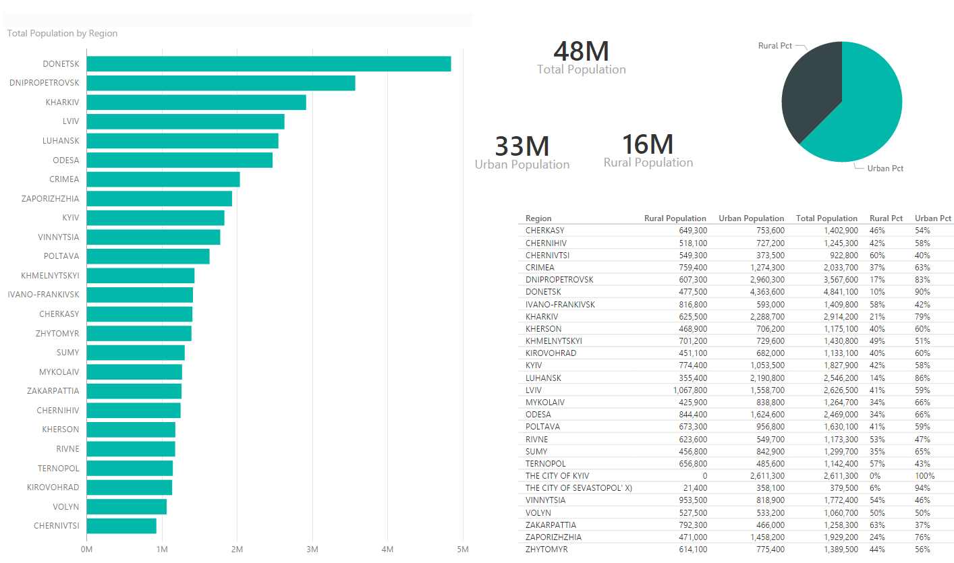

Heat map showing a potential correlation between the population of a region and the number of incidents:

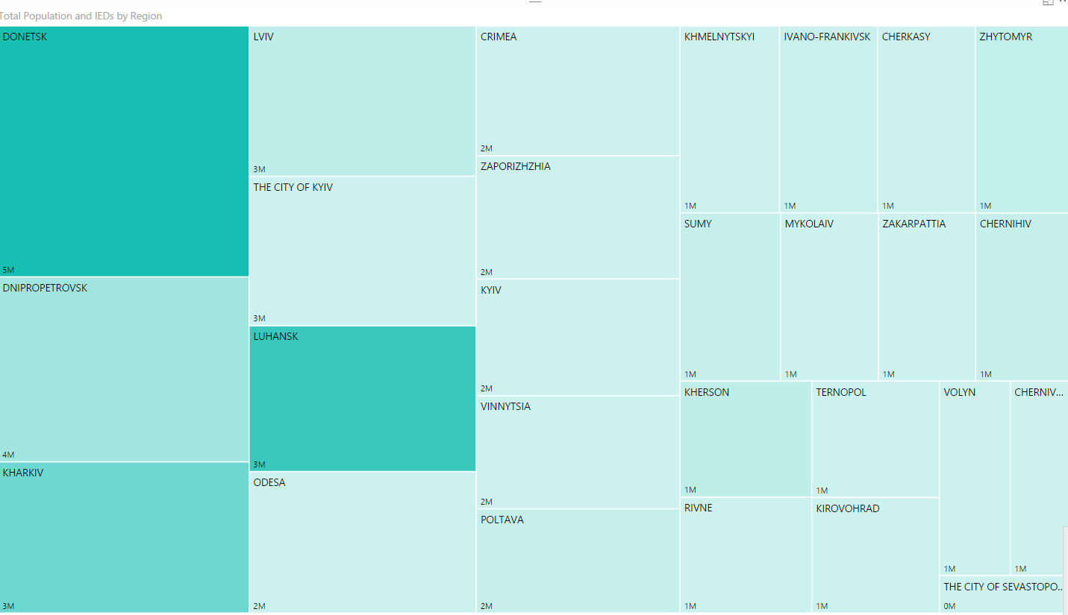

Bubble graph showing regions by number of IDEs, Population and degree of urbanization. The size of the bubbles is the fatalities resulting from the incidents.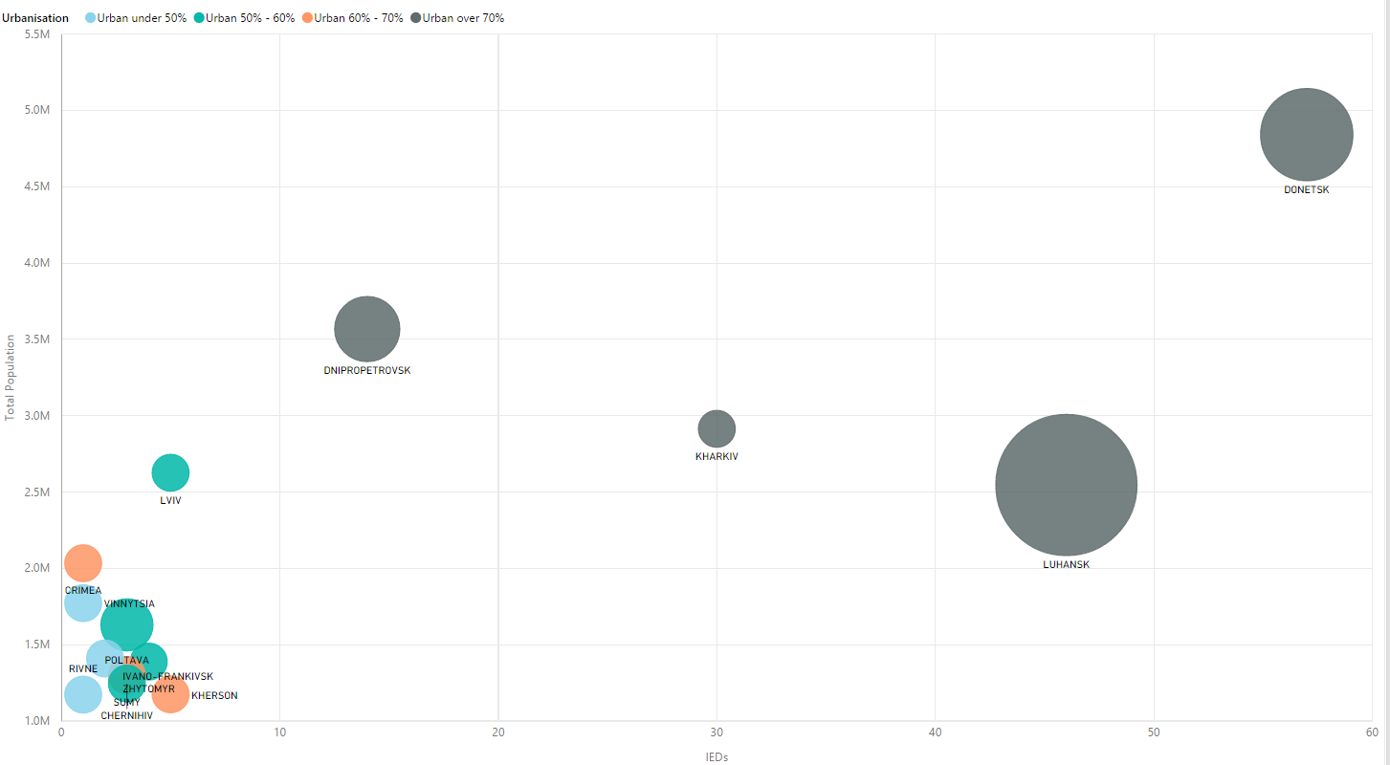

### Other Sources

Directly on the web, we found a Ukraine map showing the percentage of Russian speakers by regions. This should correspond to the data on language that is available in the Ukraine census data.

<http://www.cnn.com/interactive/2014/02/world/ukraine-divided/>

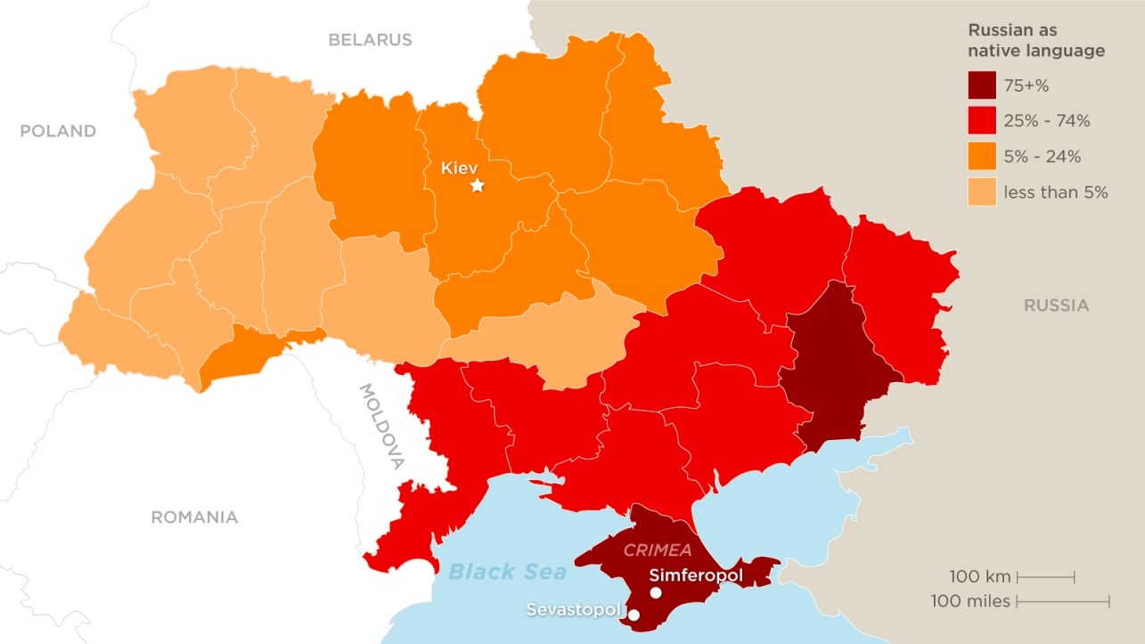

# Visualization Design

## Inspirations

### Map and Timeline

<http://www.bloomberg.com/graphics/2015-atm-bombers/>

This visualization shows the geo-temporal aspects of U.K. ATM bombing incidents. The webpage itself has a very strong storytelling design.

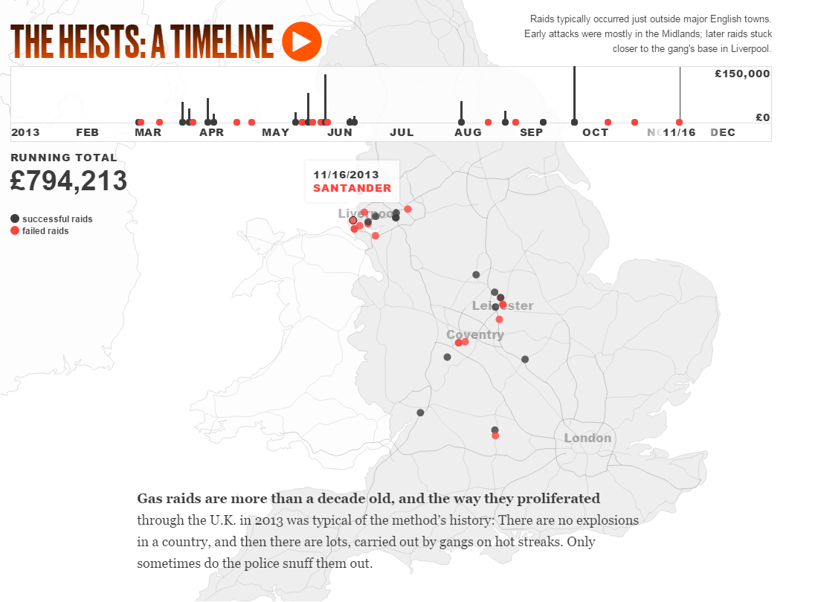

### Linked Views

<http://www.kms-world.com/solutions/industries/oil-gas>

This visualization links multiple data aspects together with an interesting use of colors.

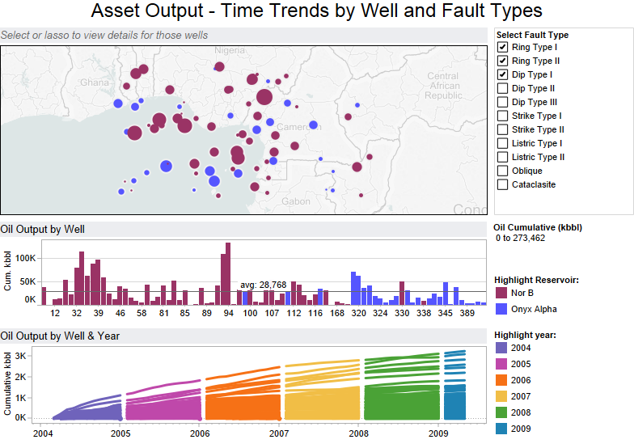

### Interactive Storytelling

<http://vis.stanford.edu/files/2010-Narrative-InfoVis.pdf>

This visual does a great job at guiding the reader through the visualization and highlighting key events, while at the same time introducing more context and bridging the gap between story and interactive visual.

Afghanistan: Behind the Front End. Financial Times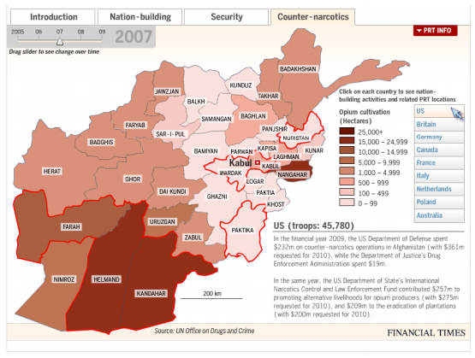

### Visualizing Text

<http://jonathanstray.com/a-full-text-visualization-of-the-iraq-war-logs>

This visualization is a great way to look into the logs of text for the various incidents and get insights from textual data. It shows how various incidents could be related.



### Categorical Data

<https://bost.ocks.org/mike/sankey/>

A Sankey diagram of IED events types, regions, cities, numbers of killed victims and wounded persons could show patterns in the data.

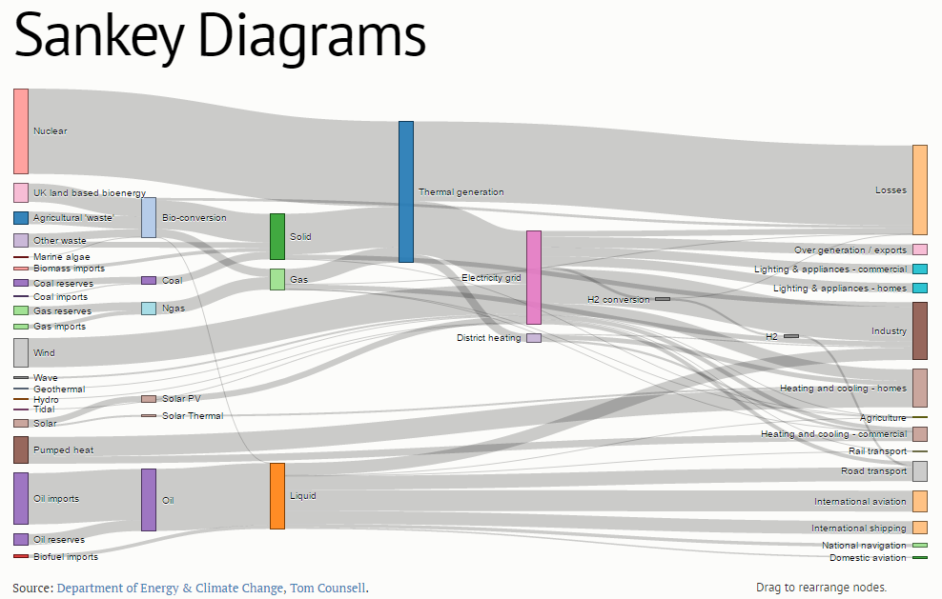

### Heat Matrix

<http://www.geotime.com/geotime(s).aspx>

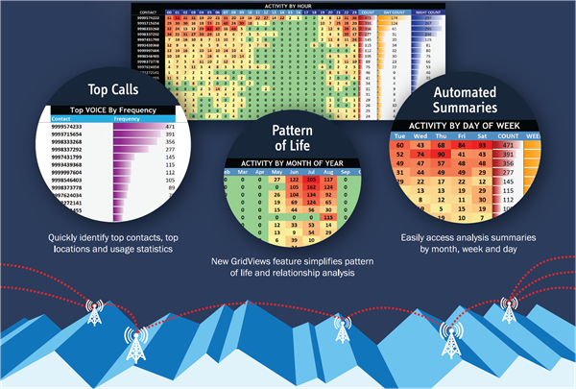

## Design Evolution – First Iteration

### First Iteration Sketch 1

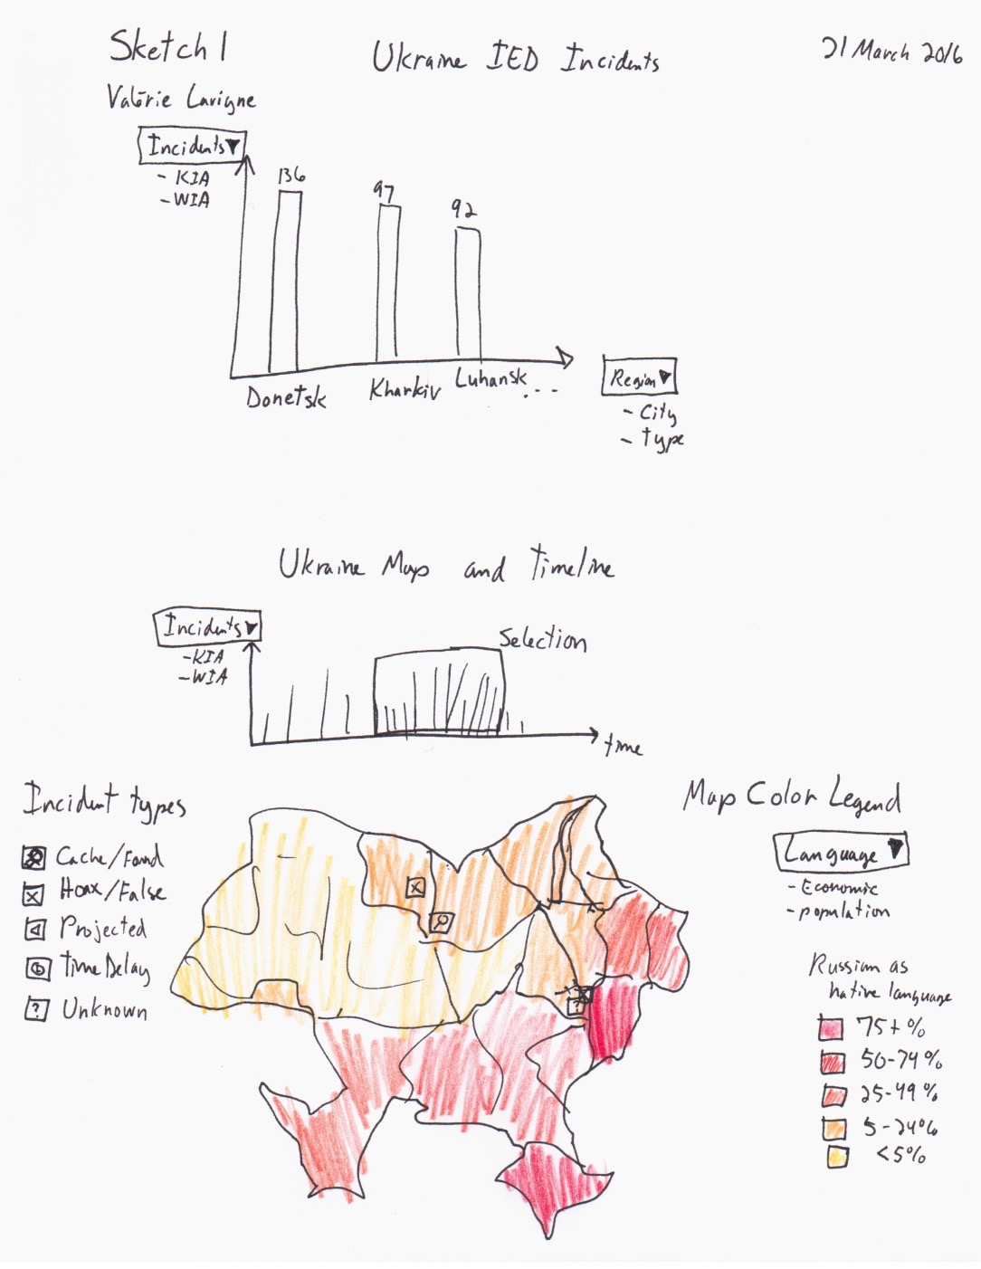

### First Iteration Sketch 2

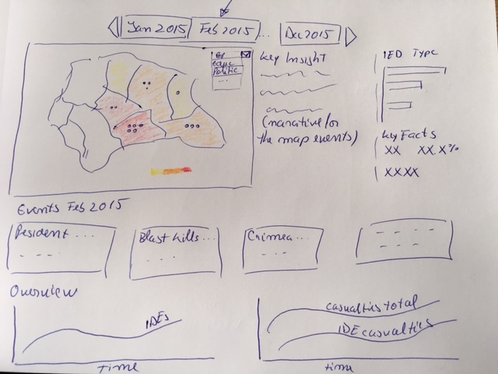

### First Iteration Sketch 3



## Design Evolution – Second Iteration

### Sketches





### Feature List

#### Introduction page

* Produce basic page
* Visualization static map screenshot in the background
* Add high-level KPIs / counters
* Animate high-level KPIs / counters

#### Map and timeline

* Find a suitable Ukraine geojson/topojson
* Create a basic Ukraine map visualization
* Find the latitude and longitude to associate with each region and city
* Display IED events as color-encoded dots on the map
* Merge data sets about regions information
* Implement map-shaped buttons to allow the user to select a specific overlay for the map (population, education …)
* Color map regions according to the user selection
* Create a IDE timeline visualization and use that to brush the main map
* Create a total IED events over time bar chart that will also act as a filter for the map
* Add IED events tooltips with more information about the event
* Add region tooltips with more information about the region
* Insert mini version of the secondary visualizations
* Prepare and create a text visualization to help with the guided navigation

#### Text analysis

* Parse text
* Display a word network
* Add a details view with samples of text with the selected word
* Create the log timeline

#### Sankey Analysis

* Produce a Sankey diagram with the IED events data
* Produce additional Sankey diagrams showing other relations within the data

#### Storytelling

* Produce the overall webpage layout frame
* Decide on a guided exploration flow

### Storyboard





### Storytelling









**Feedback from peer Evaluation**

|  |  |
| --- | --- |
| Question 1: From the prototype sketches Where and When did the incidents happen? Imagine how you can proceed to find out in which regions had high incidents rate. Can you tell around where and When were the most IED events? |  |
| Nick: | From what I can see: As the user drags the time slider left to right, IED events will appear in the map below and the charts on the right will update. To determine the region with the highest incidence of IEDs I would drag all the way from left to right once through to see which areas of the time slider had the most as well as the charts on the right and the most plot points in the map. |
|  |  |
| Khaladkar: | I think as far as the When part of the question goes, the interactive slider above the map would be my choice to explore the visualization. I can see the number of IED explosions through the little bars below the slider and choosing the position on slider is the best way to answe the "When" part. |
|  | For the where part, I would be inclined to visually see the map and click on the region that shows the highest spots. Once the user clicks on the map, he can see how the peripheral visualizations respond and explore further. |
|  |  |
| Kliyara Philip | Yes, When - Slider on top should give the user an indication when the most number of incidents occurred. |
|  | Where - The Bar chart for region should tell you which region had most number of incidents, clicking on which should show the data on the map. |
|  |  |
| Quesion 2: From the prototype sketches provided, what do you understand from our story line flow? |  |
| Nick: | There will be an introduction with some interesting facts as well as some context to the Ukraine conflict. The user will then be guided first to an overview of where IED events are occurring in Ukraine and then to section on how the incidents breakdown and finally to an animated word cloud. |
|  |  |
| Khaladkar: | The initial introduction page gives a high level understanding of the importance of the issue. I see that as a concise summary to get the user engaged into exploring further. |
|  | The user is then directed to what one would call as the "core" of the visualization. The When & Where part of the question. I think the positioning is right as most users would be interested in seeking these answers from the visualization. |
|  | The next pane is used to answer any follow-up questions about IEDs that the user might have. Looks like the Sankey has IED types on left and something else on the right. Perhaps, if the data is available, I would be interested in knowing how harmful is a particular type of IED? (# of victims and # of injured on the right side) |
|  | The last part is an attempt to answer "How". As a user, I dont think the word cloud provides much of an insight in this department. Its going to be a gathering of all those ominous words that are used to report such unfortunate incident. |
|  |  |
| Kliyara Philip | Summary statistics page with the option to go to 3 separate views - where & when, what and how? |
|  | Does not look like there is any interaction between view 2 and 3(No arrows between the two). Having that would add continuity to the story. |
|  | For instance if time filter carries from view 1 to 2, it will keep the data relevant between the two views. |
|  |  |
| Any additional feedback: |  |
|  |  |
| Khaladkar: | I think the overall idea is very interesting. Here's another comment I had - |
|  | 1. The donut on the top right corner has 3 elements - vicitims, injuries and incidents. And that seems to be a uniting theme for the different visualizations. Which works great. But somehow the donut seems to be violating tufte's data integrity principle. The 3 elements are not on the same scale. |
|  |  |
| Kliyara Philip | My assumption - An incident results in killed and injured numbers. |
|  | Do-nut Chart - Incidents and Injured,Killed does not seem to be at the same granularity. One would assume an incident results in killed and injured, |
|  | and therefore they cannot be on the same level. |
|  | Encoding on map - the three circles for an incident will overlay as they will have the same lat, long. It would be hard for the user to decipher. |
|  | Slider Chart - Similar issue as do-nut chart, data points not at the same granularity. |

**Redesign**

|  |  |
| --- | --- |
| Why are we doing this visualization? | Where and When did the incidents happen? |
| What kind of incidents were they? | What kind of incidents were they? |
| How were incidents related? | How were incidents related? |

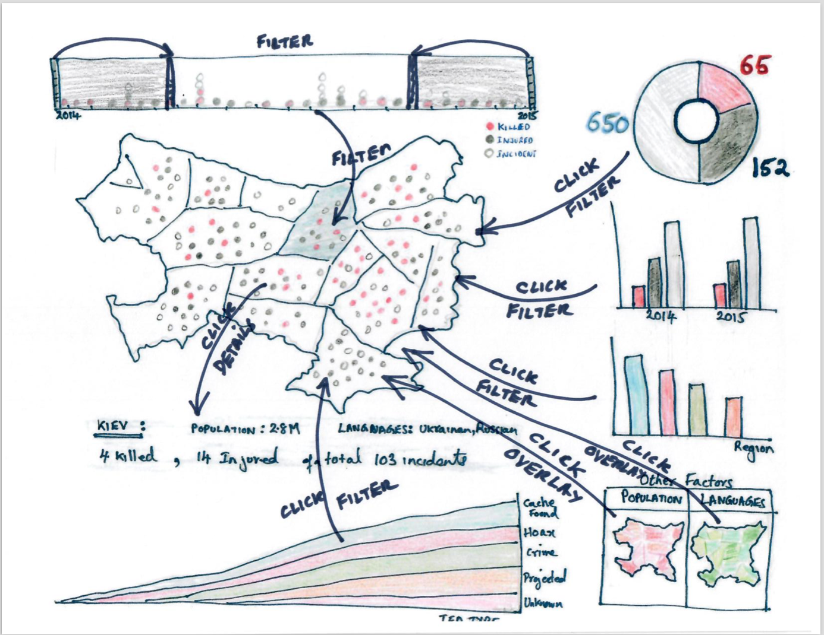

# Implementation

## Project Timeline

|  |  |  |  |  |  |  |
| --- | --- | --- | --- | --- | --- | --- |
| Visualization Component | Feature | Apr 11  Final Design | Apr 18  Project V1 | Apr 25  Project V2 | May 2  Final Project | Must Have |
| Introduction Page | Produce basic page |  |  | x |  | Yes |
| Visualization static map screenshot in the background |  |  | x |  | No |
| Add high-level KPIs / counters |  |  | x |  | Yes |
| Animate high-level KPIs / counters |  |  | x |  | No |
| Map and timeline | Find a suitable Ukraine geojson/topojson | x |  |  |  | Yes |
| Create a basic Ukraine map visualization | x |  |  |  | Yes |
| Find the latitude and longitude to associate with each region and city | x |  |  |  | Yes |
| Display IED events as color-encoded dots on the map |  | x |  |  | Yes |
| Merge data sets about regions information |  | x |  |  | Yes |
| Implement map-shaped buttons to allow the user to select a specific overlay for the map (population, education …) |  | x |  |  | Yes |
| Color map regions according to the user selection |  | x |  |  | Yes |
| Create a IDE timeline visualization and use that to brush the main map |  |  | x |  | Yes |
| Create a total IED events over time bar chart that will also act as a filter for the map |  |  | x |  | No |
| Add IED events tooltips with more information about the event |  | x |  |  | Yes |
| Add region tooltips with more information about the region |  |  | x |  | No |
| Insert mini version of the secondary visualizations |  | x |  |  | Yes |
| Prepare and create a text visualization to help with the guided navigation |  |  |  | x | No |
| Text analysis | Parse text | x |  |  |  | Yes |
| Display a word network |  | x |  |  | Yes |
| Add a details view with samples of text with the selected word |  | x |  |  | No |
| Create the log timeline |  | x |  |  | No |
| Sankey Analysis | Produce a Sankey diagram with the IED events data |  | x |  |  | Yes |
| Produce additional Sankey diagrams showing other relations within the data |  |  | x |  | No |
| Storytelling | Produce the overall webpage layout frame | x |  |  |  | Yes |
| Decide on a guided exploration flow | x |  |  |  | Yes |